**Test Procedure for the timing variation measurement using 2 XVP-1801 cards and Mateb2 software application.**

Test Setup:



Test Procedure:

Step 1:

Connect as Test Setup description. Network connection should be done with cross over network cable if direct connect to PC else regular network cable is fine. Ethernet 1 port should be used on the Densite2 frame. The PT5300 Black out should be set in NTSC and the HD out should be in 1080I/29.97Hz.

Step 2:

Set the Densite2 controller IP via the controller card menu. See attached: ”Densite2 Controller Menu.pdf” for the IP configuration. The controller menu section “ETH1 Option” should be set in “DHCP” “DISABLE” mode. Once the “IP ADDRESS”, “NETWORK MASK” and “GATEWAY”(If necessary) are set reboot the controller card. This can be done via the last card menu: “CTRL EXECUTION” or by controller card removal/re-insertion. Once rebooting is done, verify if IP configuration is fine. If the configuration is OK, you should be able to PING the frame with your PC.

Step 3:

Copy the Folder “MSG-5300 GPS Timing Measurement Stability Tools” to your PC. This application is self-contain and therefore can be copied anywhere. Double click on the “MATEB2 Start.exe” application. Set the Controller IP Address. In your case it will be the same for both cards. The card slots number are already properly set for your Densite2 frame. “Save” your configuration. “Run” the application and you should see the following status validation in the Log section:

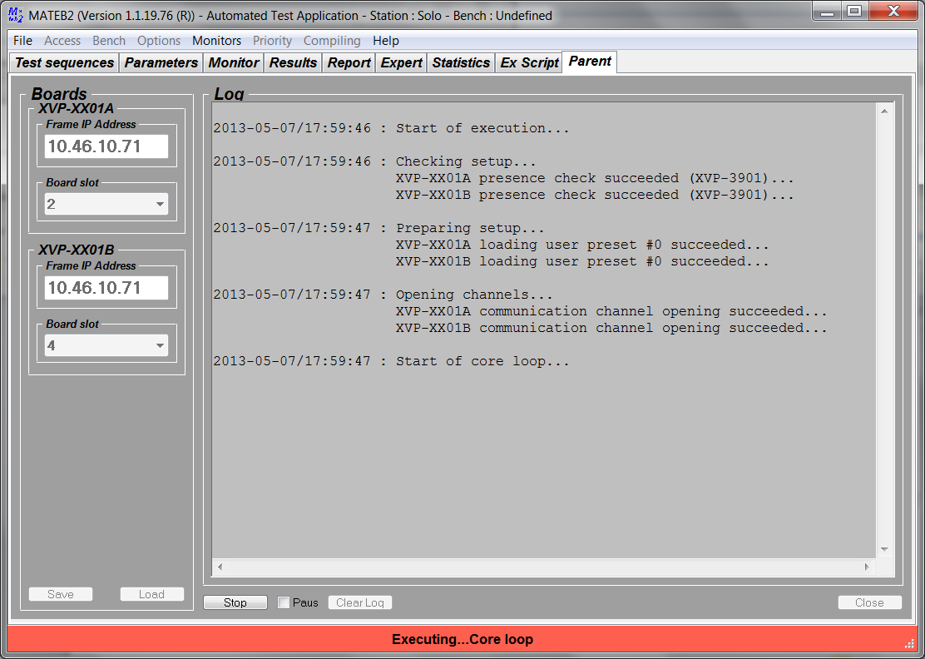

The Application is now logging in the log window all timing variation and errors. The results are saved to a .txt file created in the MATEB2/Logs folder. This file is date and time stamp. The logs are saved every 5 minutes. A new file will be created at every stop and re-run sequence.